Bridge Blueprint


An A-Z Guide to Teaching and Learning
2023/24
At Godmanchester Bridge Academy, we value the talents and skills of all staff. This approach allows staff the freedom to draw on and to develop their expertise.

We also believe that pupils have a right to high quality teaching and learning and that familiarity with agreed approaches and routines benefits all pupils.

This document outlines the GBA approach to teaching and learning and what children, parents and staff can expect from the school.
Blueprint – (noun)
a complete plan that explains how to do or develop something.

Cambridge Dictionary


Godmanchester Bridge Academy
Contents

Please CTRL + click on the heading below to take you to the information you need.

Introduction 4
Assessment 5
Behaviour Management 5
Curriculum Planning and Information 6
Displays 6
Foundation Subjects 7
Handwriting 7
Knowledge Organisers 7
Marking and Feedback 8
Maths 9
Morning Retrieval Task 9
Music 10
PE 10
Phonics 11
Playtime and Lunchtime 11
PSHE 11
Reading 11
RE 12
Science 12
SEND and Inclusion 12
Spelling (KS2) 13
Writing 15
Vocabulary 15

Introduction

We recognise there are differing approaches to teaching and learning and that children respond to a variety of strategies therefore we do not follow a prescriptive way of teaching or learning at GBA. However, Rosenshine’s Principles of Instruction underpins our pedagogical thinking.
These principles come from three sources: (a) research into how the brain acquires and uses new information, (b) research on the teaching practices of teachers whose pupils have made the most progress and (c) findings from studies that taught learning strategies to pupils. The fact that the instructional ideas from three different sources supplement and complement each other gives us faith in the validity of these findings.
Teaching involves helping pupils develop strong, readily accessible knowledge. It’s important that background knowledge be readily accessible, and this occurs when knowledge is well rehearsed and tied to other knowledge. The most effective teachers ensure that their pupils efficiently acquire, rehearse, and connect background knowledge by providing a good deal of instructional support. Our teachers provide this support by teaching new material in manageable amounts, modelling, guiding pupil practice, help pupils when they make errors, and provide sufficient practice and review.

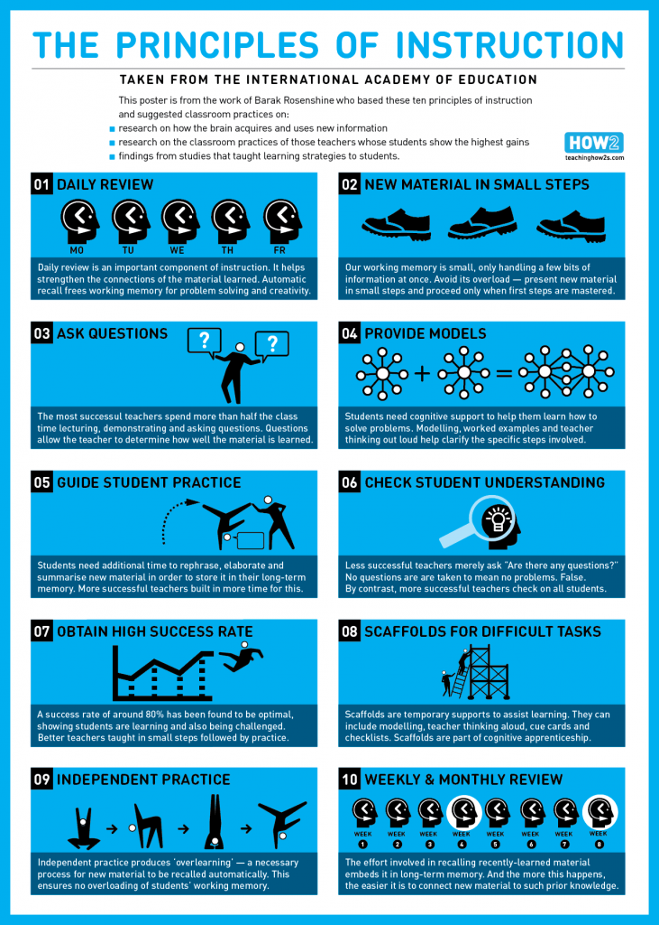

Assessment
- Teachers have the responsibility to assess all pupil’s learning.
- This informs the planning of Quality First Teaching and any interventions that pupils require to keep up or catch up.
- There is a combination of formative and summative assessment.
- From Y1, Summer 1, we use NFER and past SATs papers to assess Reading, GPS and Maths each term.

Behaviour Management
- All staff must follow the Behaviour Policy consistently as everyone needs high expectations for behaviour.
- We will use dojo points as house points to reward positive behaviour as well as certificates.
- At the start of each term, we dedicate lessons to our Behaviour Curriculum so that the children have a clear understanding of what is expected of them and what they can expect of us.
- When necessary, we also revisit these themes in assemblies throughout the year.

Curriculum Planning and Information
- Our school website includes details of the progression within each subject as well as an overview for each year group. These plans are co-produced by SLT, Subject Leaders and Class Teachers.
- Plans are reviewed each July and updated on the school website before the start of the new academic year.
- Teachers provide parents with a termly overview of the curriculum for their child’s year group by Class Dojo.

Displays
Displays are used to celebrate pupils’ achievements and to aid learning.

Corridor Displays
- Most of the corridor/shared area displays have a curriculum focus and showcase the work that our pupils do during their time at the school. These displays tell the journey of a subject from the FS to Year 6.
- These Subject Displays are changed once a year.
- Subjects leads are responsible for their Subject Display.
- Children’s work is celebrated on an allocated display board in the corridor outside of their classroom and on a ‘Welcome display’.

Classroom Displays
- Displays within the classroom tend to be in the form of Learning Walls
- Class teachers are responsible for the working walls within their classroom.
- All displays must fit on boards and there should be nothing else on walls, cupboards or windows in the classrooms.
Each classroom must have:
- Values are displayed above the interactive white board
- Behaviour Stages are displayed below the teaching whiteboard
- English working wall – The Write Stuff current, accessible to children, aids to learning
- Sentence Stacking Wall
- Maths working wall – current, accessible, aids to learning, key vocab, modelling calculations
- KS1 Phonics with the phonemes taught that week and common exception words/
- KS2 spelling display with common exception words and recent spelling patterns
- History/Geography display – initial to capture interest. Current subject vocabulary. Any relevant subject matter to aid learning.
- Science display – Current subject vocabulary, Scientist ask ‘Why?’ poster, any relevant subject matter to aid learning.
- Reading Corner KS1 within the classroom – clear and inviting reading area.
- Reading Tree KS2 in the corridor – clear and engaging

Foundation Subjects
- We use the Kapow scheme to deliver Computing, Art, DT, History, Geography and MFL.
- Kapow fully supports teaching using Rosenshine’s Principles.
- We block subjects into units of work. This means that children study a subject for longer periods in greater depth for half of the term and then study a different subject for the remainder of the term.
- As each term differs in length each year, we have chosen to block subjects. This may mean that a topic begins in one term and then continues in the next. In total, there are 18 to 20 weeks of each subject taught across the year.
- Work is recorded in each subject’s workbook.
In broad terms, Foundation Subjects are covered in the following way:
 | Unit 1 |  | Unit 2 |  | Unit 3
Y1 | C, H, A | G, DT | C, H, A | G, DT | C, H, A | G, DT
Y2 | C, H, A | G, DT | C, H, A | G, DT | C, H, A | G, DT
Y3 | C, H, A | L, G, DT | C, H, A | L, G, DT | C, H, A | L, G, DT
Y4 | C, H, A | L, G, DT | C, H, A | L, G, DT | C, H, A | L, G, DT
Y5 | C, H, A | L, G, DT | C, H, A | L, G, DT | C, H, A | L, G, DT
Y6 | C, H, A | L, G, DT | C, H, A | L, G, DT | C, H, A | L, G, DT
Key: C = Computing, H = History, A = Art, L = Languages, G = Geography, DT = Design
Where possible Foundation Subjects are taught across the school during the same time frame to allow for effective monitoring by Subject Leaders.

Handwriting
- from Year 1 to 6 we follow Letterjoin as our handwriting scheme. The lesson plans are on the One Drive for teachers to access. They are also on the online website. The link is here: Log In (letterjoin.co.uk)
- Each class has 2 sessions of handwriting per week.
- Class teachers model our handwriting in each lesson.
- Handwriting practice is recorded in the spelling/handwriting book.

Knowledge Organisers
- Knowledge Organisers are used in Science, History, Geography, DT, Art, Computing, and MFL. These cover subject specific vocabulary with definitions and key facts.

Example of a Knowledge Organiser

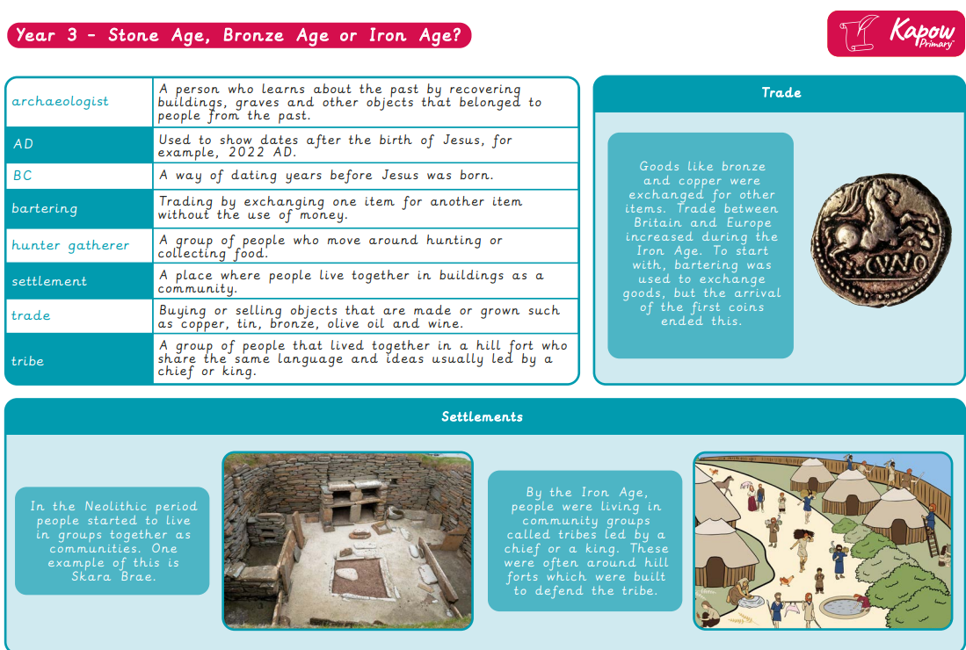

- How to use Knowledge Organisers
- Give to the children before the start of a topic to encourage discussion and prior research. What information has sparked their interest? Do they have any questions? Send a copy home on Class Dojo.
- Use as a regular retrieval tool. Mix up practice using short, low stakes quizzes, games, partner discussion. Ask higher-level ‘Why?’ questions to stretch the children’s understanding and add detail.
- Use to identify knowledge gaps throughout the topic.
- Display an enlarged copy on a Working Wall, encouraging children to add information around it during the topic.
- Use to strengthen teacher knowledge in a subject area.
- Glue into the children’s topic books for regular reference during the topic.
- Make links with the Knowledge Organisers the children met previously to help them understand how their learning connects and how their new knowledge links and builds upon it.
- Use as a handy spelling and vocabulary reminder. Always keep it visible and expect the children to use subject vocabulary correctly.
- Use as guided reading texts. This way, you can help children read the information and check they understand it.

Marking and Feedback
Foundation Stage
- Feedback and guidance will be given to each child in the form of verbal feedback.
- When suitable, written feedback will be provided in green pen.
- Codes will be used to show the level of input/support – independent work, adult support, teacher assisted.
- Next steps will be shared with each child verbally.
- Seesaw will be used to signal progress or achievement of task (during independent learning).
- Teaching staff will assess work in Read Write Inc using arrows.

Key Stage 1/2
- All marking will be done in green pen and reflect the L.O.
- Verbal and/or written feedback will provide guidance to children on how to improve and make the next steps in their learning (including presentation).
- Teachers will assess work against L.O. (using arrows) and, if relevant, success criteria (using arrows).
- Where appropriate, children will assess their own work.
- Marking codes will be used to indicate level of support (see below).
- Children will be given time to reflect on feedback given and respond in pink pen when necessary.

Marking and Feedback Codes
I – Independent *
WS – With support – followed by adult’s initials
WD – With discussion
or VF – Verbal feedback.
*In KS1/2, independent work is only signalled if children would usually work with support.

Maths
- We use the White Rose Scheme of Work for Maths
- There are 5 lessons per week, 1 per day.
- KS1 also have 2 Mathletics sessions per week.
- KS2 also have 1 Mathletics session and 2 Times Tables sessions per week.
- Homework is set weekly on Mathletics.
- Mathletics is checked weekly by the teacher to analyse any misconceptions and support the pupils in their learning.
- A Cold Task is set before the current topic is taught to inform planning and there is a Gold task at the end of the topic to assess understanding.
- Maths is recorded in Maths workbooks.

Morning Retrieval Task
- Each morning begins with a 15-minute retrieval task during registration.
- These tasks are designed as low-stakes quizzes of prior learning i.e. with questions about what we have covered last lesson, last week, last month/term.
- Maths flashbacks are a useful resource for this activity. Teachers to design similar tasks for English.
Examples of Maths Flashbacks:
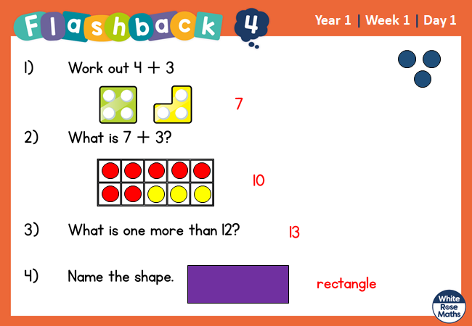

Example of a Flashback that covers different subject areas:
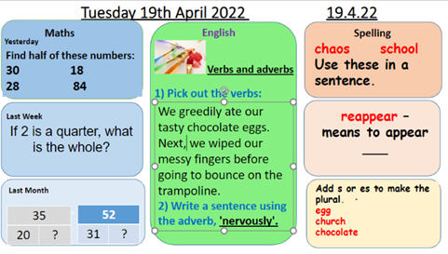

Music
- Music is taught by a specialist teacher to Years 1-6.
- There is a 30-minute singing assembly fortnightly on a Friday.

PE
- PE is taught twice in each full teaching week, one outdoor and one indoor.
- There are sports coaches that deliver sessions, but others are teacher taught using the Cambridgeshire scheme.

Phonics
- As soon as children join the EYFS, they begin our phonics programme (Read Write Inc).
- In EYFS we also follow the RWI ‘Making A Strong Start’ guidance to build up to a 30 min daily lesson as soon as possible.
- RWI is taught for 30 mins per day throughout the EYFS and KS1 until pupils leave the programme in Year 2, Autumn 2.
- If the children have not completed Read Write Inc by Year 2, Autumn 2, they will continue to have 1:1 Phonics intervention.
- In Year 1, there is an additional 15 min daily session to prepare pupils for the for Phonics Screening Check.

Playtime and Lunchtime
- At the start of playtime, children are led outside by adult.
- EYFS children join KS1 pupils on the playground once they have settled in the Autumn term.
- KS2 play in the MUGA. See timetables for timings.
- All staff share responsibility for supervising children at breaktime. This rota is organised by Phase Leaders.
- First aid is administered by staff on duty and the teacher is informed.
- Children take their water bottles outside.
- At the end of playtime, one whistle is blown to indicate that the children should stop playing.
- On the second whistle, children line up quietly.
- When ready, an adult leads the children back into school.
- We use the OPAL play initiative at lunchtimes to support children’s play.
- All TAs are trained as playleaders and facilitate the OPAL 16 Areas of Play.
- Pupils have access to the full site at lunchtime and enjoy a range of activities.

PSHE
- We follow the 2020 Cambridgeshire Primary Development Programme.
- Pupils are taught PHSE in every full teaching week,
- Some content is also taught through assemblies and whole school events.
- A written outcome should be recorded in books in 50% of lessons. Some form of evidence should be completed for every lesson; this could be a photo on seesaw, voice recording, video clip etc. Work is recorded in the RE/PHSE book.
- A letter must be sent to parents to inform them when Relationships and Sex Education will be taught.

Reading
EYFS/Key Stage 1
- Initially, reading is taught using Read Write Inc.
- Year 2, pupils move onto Guided Reading lessons once they finish the Read Write Inc program.
- Pupils will take home 3 books per week;
  - the Read Write Inc book they are currently working on at school,
  - a home reading book at their phonics level and,
  - a Reading for Pleasure book.
- Reading Diaries are checked each week on Friday

Key Stage 2
- Each class has 2 sessions of 30-minute Whole Class Guided Reading per week.
- These sessions follow the structure and visuals of The Teach Hub. Although The Teach Hub provides most plans for these activities, staff create their own plans using the same style.
- Pupil work is recorded in their Guided Reading Workbook which have a half termly overview of Reading skills and texts.

Shared Read
- There are 5 shared reading sessions in EYFS/KS1 and 3 in KS2.
- Pupils will develop a love of reading by being read to by an adult and talking about books.
- Teachers will use books from the age appropriate 100 recommended reads to share.

Accelerated Reader
- When ready, Year 2 pupils are given a Star Test to help staff ensure that they are given the correct level of book within AR.
- Pupils continue to take a Star Test every half term. Class Teachers review the outcomes of the test and set targets for each pupil.
- Targets are written on a bookmark for the child to have on their tables and to use as a bookmark.
- Children are expected to read to or with an adult at home a minimum of five times a week.
- Reading Diaries are checked each week on Friday.
- A DOJO Point for Reading is awarded for each time that a child has read with an adult at home.
- Once a child has finished an AR book, they complete the relevant quiz. Teachers monitor the results of these quizzes and use the diagnostic tools to identify which areas require further focus, for an individual or as a class.

RE
- We follow the Discover RE scheme.
- Pupils are taught RE in every full teaching week and work is evidenced in RE/PHSE book.

Science
- We plan using the planning template and PLAN resources
- There are 12 lessons per unit and work is recorded in the Science book.

SEND and Inclusion
- Teachers follow a graduated response to SEND, starting with Quality First Teaching and reasonable adjustments to meet the needs of every child. This can be seen through our intentional planning and adaptive teaching which is designed to be as inclusive as possible.
- Through on-going assessment by teachers, some pupils may be identified as requiring additional support.
- This provision is facilitated by the class teachers, and they monitor its impact.
- Where appropriate, pupils would then move onto the Assess Plan Do Review process which monitors targeted interventions and their impact.
- For some pupils this process is successful, others may need additional support and intervention from outside agencies and professionals.

Spelling (KS2)
- We follow Read Write Inc Spelling practise.
- Link to the website is: Login (oxfordowl.co.uk)
- There are two spelling lessons per week.
- Year 2 move onto the spelling program in Autumn 2.
- This is recorded in the Spelling/Handwriting book which include a half termly overview of spelling rules to be taught.
Timetables
Example EYFS Timetable

Example KS1 Timetable

Example KS2 Timetable

Writing
- Writing is taught using ‘The Write Stuff’ by Jane Considine in a daily writing lesson, recorded in English books.
- Each unit lasts for 3 weeks and there is one fiction and one nonfiction unit taught each half term.
- Regular assessment of writing allows us to adapt provision to meet the needs of our class. For example, we have found that we have needed to adapt the grammar element of The Write Stuff.
- This is recorded in the English book.
- From Autumn 2, there is also 1 Free Write lesson per week for pupils from Year 2 to 6. There are to types of focus for the Free Write session:
  - independently practise and apply writing skills learnt in The Write Stuff when producing a piece inspired by a picture from Once Upon A Picture, or
  - produce a piece of cross curricular writing demonstrating their knowledge in Foundation subjects and Science.
- Free Write pieces are recorded in the back of the English book or the relevant subject book.

Vocabulary
- We recognise the importance of developing each child’s vocabulary. Planning indicates the vocabulary that teachers will introduce within a topic.
- Knowledge Organisers also include details of vocabulary to be taught.
- Teachers check pupils acquisition and understanding of vocabulary during lessons.

